Download and run https://sourceforge.net/projects/xampp/  
Default path should be C:/

Open cmd prompt or git bash and

cd C:\xampp\htdocs

Then run  
git clone <https://github.com/DarylTeh/CSIT314>

It should look like this

Then start all of these, if you have issues with MySQL, winkey -> services then search for MySQL and stop it. Then click the start button on XAMPP.

Next open chrome/edge and go to

<http://localhost/phpmyadmin/index.php>?

Click on new at the left side of your screen

Database name: realestatephp and click create

Click import at the top and choose file C:\xampp\htdocs\CSIT314\DATABASE FILE\realestatephp.sql

You should see the database now

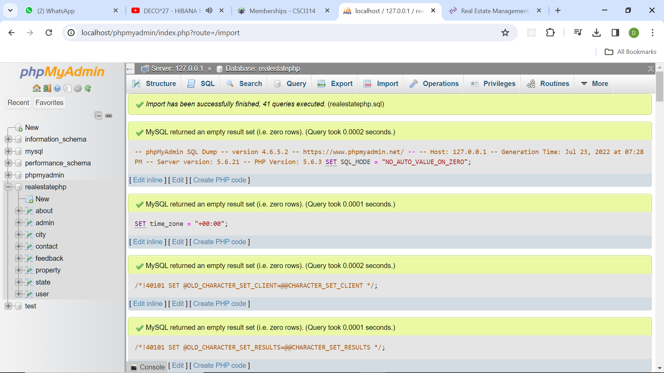

In chrome/edge go to <http://localhost/CSIT314/> and you will be at this page

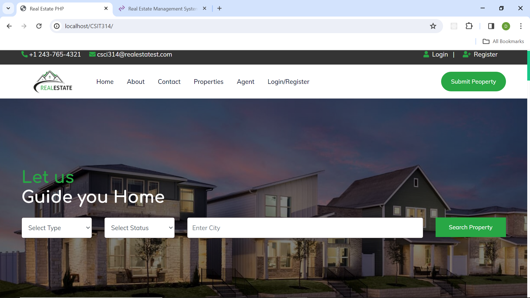

You are done thx